Academic Year: 2024-25 | Year: First Year | Term: I
Roll No.: | 11
Name: | Riddhee Sandeep Kulkarni
Subject: FCP
Assignment No.: | 28
Title: | File Copy
Date:

Contents
1. Theory (Logic) 2
2. Pseudo Code 2
3. Program Code 2
4. Output 2
5. Conclusion 2

THEORY:

This code demonstrates file handling by copying the content of one file to another, ensuring

proper error handling during file operations.

PSEUDO CODE:

Step 1: Start

Step 2: define variables

Step 3: define main function

Step 4: accept file names from user

Step 5: write code to copy content from one file to another

Step 5: print output

Step 6: end

PROGRAM CODE:

#include <stdio.h>

#include <stdlib.h>

int main()

{

FILE *sourceFile, *destFile;

char sourceName[100], destName[100], ch;

printf("Enter the source file name: ");

scanf("%s", sourceName);

printf("Enter the destination file name: ");

scanf("%s", destName);

sourceFile = fopen(sourceName, "r");

if (sourceFile == NULL)

{

printf("Error: Cannot open source file.\n");

exit(1);

}

destFile = fopen(destName, "w");

if (destFile == NULL)

{

printf("Error: Cannot create destination file.\n");

fclose(sourceFile);

exit(1);

}

while ((ch = fgetc(sourceFile)) != EOF)

{

fputc(ch, destFile);

}

printf("File copied successfully.\n");

fclose(sourceFile);

fclose(destFile);

return 0;

}

OUTPUT:

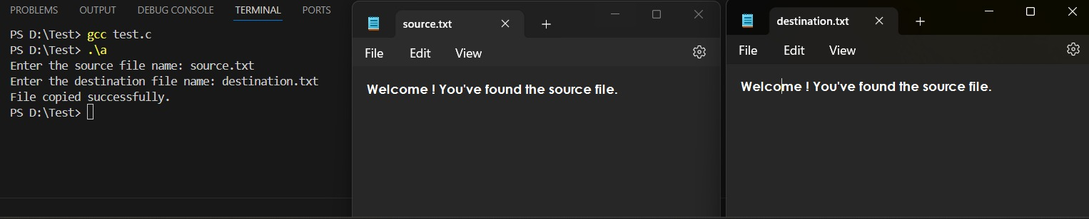

CONCULSION:

Code is run successfully, required output received

